Instructions for the Wild Side Tattoo Staff
Thanks for helping us out. We had a great time doing the “beta” game with you 2 weeks ago. (Pantera was awesome!) Here’s what you should do tonight:

Players from each team will arrive, and you should

- ASK WHAT TEAM THEY ARE FROM, AND IF THEY ARE THE FIRST TO ARRIVE, GIVE THEM THEIR BROWN PAPER BAG.
- SHOW THEM THE MENU
- TRY TO DO THEIR PIERCINGS/TATTOOS AS QUICKLY AS POSSIBLE.

THE PASSWORD YOU NEED TO PLAY THE TAPE FOR THEM IS A CAR LICENSE NUMBER: SG137IU
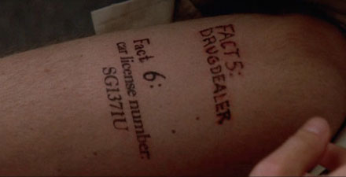

Some rules & guidelines for you:

- it’s OK to take bribes, but you should look for big bribes. Don’t take a bribe from the first or second (or even third) place team unless it’s HUGE. Make the winners work to win. When it gets to be really late (6-9th place) you can go much easier on them.
- tattoo size should be about 1”-1.5” long, 1” high.
- It’s OK for them to get piercings on more than 1 person.
- If you need to talk to an organizer, try:
Walter: 206 xxx-xxxx
Joe: 206 xxx-xxxx

